20. AIM: To compute various logical operations using 8085 processor.

ALGORITHM:

1)      Load data to accumulator.

2)      Load another data in register.

3)      Perform logical operations like AND, OR and XOR (Use ANA, ORA, XRA) with the accumulator content.

4)      Store the result in specified memory location.

PROGRAM:

AND OPERATION:

MVI A,06

MVI B,04

ANA B

STA 2500

HLT

OR OPERATION:

MVI A,07

MVI B,06

ORA B

STA 2000

HLT

XOR OPERATION:

MVI A,03

MVI B,08

XRA B

STA 2000

HLT

INPUT&OUTPUT:

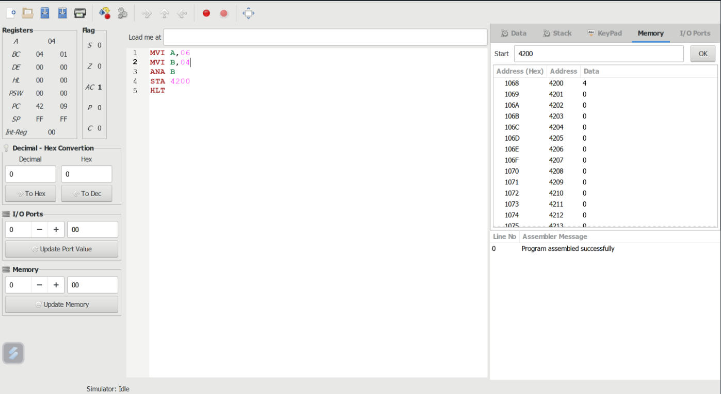

RESULT: Thus the program was executed successfully using 8085 processor simulator.